# 1. Free State

The Free State province has 7 weather gauge stations that measure and record the precipitation in mm and the temperature in $℃$. The stations are Bethlehem, Bloem Stad, BloemWo, Fauresmith, Vrede and Welkom. In this research the data of each station is considered.

# 1.1 Temperature

### 1.1.1 Pettitt test

The nonparametric Pettitt test is a technique of detecting significant change points as mentioned in chapter 2. The nonparametric Pettitt test does not consider the distribution the data follows. The null hypothesis is that no change-point exists and alternative hypothesis is that change-point does exist. The significant change points would be identified where the p-value is less than 0.05 at a 5% significance level. Considering the South African Weather Services data, I find that there are change points, and they are indicated in the tables below, table 1 and table 3. Therefore, it is evident that there are change points in both precipitation and temperature at a specific point in time. Please note that the tables only display the results of the significant change points (p-value < 0.05). The results where the p-value is above 0.05, I conclude that there is not sufficient information to conclude that the change-point exists and the data is consistent over time.

* As seen in table 1 that all of the abrupt changes are upwards, there is abrupt increase in the temperature at a specific point in time in the studied stations.
* Bloem Stad and Bloem Wo have the greatest difference in temperature before and after the change-point.
* For seasonal timescales:
* In winter and Spring, out of seven stations, the same five stations have a significant change-point.
* In summer, out of seven stations, only two has a significant change-point.
* In autumn, out of seven stations, only one has a significant change-point.
* The abrupt changes started in June 1997 at Bethlehem and ended in June 2015 at Gariep Dam and Fauresmith.
* For a monthly timescale:
* Amongst the Free State stations, Vrede has the highest frequency in abrupt changes at all indicated months in table 1.
* Gariep Dam and Fauresmith has only one abrupt change in June 2015.
* Most the abrupt changes are experienced in June for most of the stations.
* For annual timescale:
* Out of seven stations, only three have a significant change-points.

Table 1: Pettitt test results for temperature

|  |  |  |  |  |  |  |
| --- | --- | --- | --- | --- | --- | --- |
| **Timescale** | **Gauge Station** | **P-value** | **Change point** | **Average Before shift** | **Average After shift** | **Shift** |
| January | Vrede | 0.0053 | 2011 | 25.3 | 27.1 | UP |
| February | Vrede | 0.0375 | 2006 | 24.8 | 28.0 | UP |
| March | Vrede | 0.0231 | 2009 | 25.0 | 26.0 | UP |
| May | Bloem Stad  Bloem Wo  Vrede | 0.0020  0.0029  0.0053 | 2011  2011  2011 | 18.6  18.8  19.6 | 23.0  23.3  22.7 | UP  UP  UP |
| June | Gariep Dam  Bloem Wo  Fauresmith  Bethlehem  Vrede | 0.0323  0.0225  0.0189  0.0048  0.0169 | 2015  2012  2015  1997  2012 | 16.1  16.4  16.5  14.7  17.0 | 17.2  19.2  18.5  19.5  19.5 | UP  UP  UP  UP  UP |
| July | Vrede | 0.0148 | 2011 | 15.6 | 18.8 | UP |
| August | Vrede | 0.0446 | 2014 | 20.3 | 24.9 | UP |
| September | Bethlehem  Vrede | 0.0089  0.0148 | 2004  2004 | 21.1  22.5 | 24.8  25.7 | UP  UP |
| October | Bloem Stad  Bethlehem  Vrede | 0.0314  0.0006  0.0053 | 2001  2001  2001 | 26.4  23.0  23.7 | 27.3  24.9  25.7 | UP  UP  UP |
| November | Bloem Stad  Bethlehem  Vrede | 0.0499  0.0398  0.0204 | 2002  2002  2002 | 27.6  24.9  25.3 | 31.8  25.9  25.8 | UP  UP  UP |
| December | Vrede | 0.0093 | 2002 | 25.5 | 29.2 | UP |
| Winter | Bloem Stad  Bloem Wo  Bethlehem  Welkom  Vrede | 0.0016  0.0029  0.0248  0.0316  0.0015 | 2011  2012  2002  2011  2011 | 16.9  19.1  16.3  19.0  17.4 | 18.9  20.5  18.4  21.2  19.5 | UP  UP  UP  UP  UP |
| Spring | Bloem Stad  Bloem Wo  Bethlehem  Welkom  Vrede | 0.0013  0.0331  0.0003  0.0157  0.0008 | 2006  2013  2002  2003  2007 | 18.2  24.2  21.7  25.2  22.3 | 18.7  25.9  22.5  26.8  24.7 | UP  UP  UP  UP  UP |
| Summer | Bloem Stad  Vrede | 0.0139  0.0010 | 2002  2002 | 28.3  25.7 | 33.0  27.5 | UP  UP |
| Autumn | Vrede | 0.0375 | 2006 | 22.6 | 25.9 | UP |
| Annual | Bloem Stad  Bloem Wo  Bethlehem  Vrede | 0.0100  0.0033  0.0018  0.0009 | 2012  2012  2002  2007 | 24.9  25.1  21.9  23.2 | 25.7  26.0  23.4  23.7 | UP  UP  UP  UP |

## 1.1.2 Mann-Kendall test

The Mann-Kendall trend test examine whether the trend in a time series data exists, and the Sen’s slope measures the direction and magnitude of the trend given the trend exists. It is said that the trend exists if the p-value is less than 0.05 and calculated Z statistics is greater than the critical value |1.645| at a 5% significance level. Figure 1 is provided below to display the Z test statistic for 7 stations for different timescales.

* All of the significant trend is upwards which highly suggest a gradual increase in the temperature in the Free State province.
* For monthly timescale:
* Vrede has a significant trend at all of the indicated months in the table 2.
* Fauresmith and Gariep Dam has no significant trend which suggests that the temperature is consistent.
* Most of the rising temperatures is experienced in october and november.
* For seasonal timescales:
* Most the rising temperatures is experienced in winter and spring.
* In summer, only Bloem Stad and Vrede have a significant trend.
* No significant trend experienced in autumn.
* For annual timescale, four out of seven stations have a significant trend.
* Bloem Stad and Vrede have the highest slope which suggest a rapid temperature increase over time in respect to other stations in the Free State.
* Bethlehem has the lowest slope which suggest slow temperature increase over time in winter and annual timescale.

Table 2: Mann-Kendall test results for the temperature

|  |  |  |  |  |  |
| --- | --- | --- | --- | --- | --- |
| **Timescale** | **Gauge Station** | **P-value** | **Z value** | **Sen’s slope** | **Trend direction** |
| January | Vrede | 0.0023 | 3.0524 | 0.08 | Upwards |
| February | Vrede | 0.0281 | 2.1962 | 0.08 | Upwards |
| March | Vrede | 0.0159 | 2.4123 | 0.08 | Upwards |
| May | Bloem Stad  Bloem Wo  Vrede | 0.0008  0.0220  0.0013 | 3.3563  2.2905  3.2158 | 0.13  0.06  0.10 | Upwards  Upwards  Upwards |
| June | Bethlehem  Vrede | 0.0009  0.0203 | 3.3115  2.3216 | 0.05  0.08 | Upwards  Upwards |
| July | Bloem Stad  Vrede | 0.0294  0.0056 | 2.1780  2.7676 | 0.07  0.09 | Upwards  Upwards |
| August | Bethlehem  Vrede | 0.0466  0.0047 | 1.9902  2.8240 | 0.04  0.09 | Upwards  Upwards |
| September | Bethlehem  Vrede | 0.0094  0.0137 | 2.5977  2.4647 | 0.05  0.08 | Upwards  Upwards |
| October | Bloem Stad  Bloem Wo  Bethlehem  Welkom  Vrede | 0.0030  0.0155  0.0000  0.0110  0.0023 | 2.9676  2.4196  4.0965  2.5426  3.0532 | 0.08  0.07  0.08  0.07  0.09 | Upwards  Upwards  Upwards  Upwards  Upwards |
| November | Bloem Stad  Bloem Wo  Bethlehem  Welkom  Vrede | 0.0054  0.0193  0.0224  0.0489  0.0011 | 2.7841  2.3392  2.2831  1.9692  3.2675 | 0.12  0.09  0.05  0.04  0.11 | Upwards  Upwards  Upwards  Upwards  Upwards |
| December | Vrede | 0.0144 | 2.4462 | 0.06 | Upwards |
| Winter | Bloem Stad  Bloem Wo  Bethlehem  Welkom  Vrede | 0.0008  0.0156  0.0076  0.0120  0.0003 | 3.3557  2.4178  2.6693  2.5110  3.6586 | 0.08  0.05  0.03  0.04  0.10 | Upwards  Upwards  Upwards  Upwards  Upwards |
| Spring | Bloem Stad  Bloem Wo  Bethlehem  Welkom  Vrede | 0.0004  0.0297  0.0000  0.0038  0.0000 | 3.3557  2.1746  4.0715  2.8988  3.9626 | 0.07  0.04  0.05  0.05  0.09 | Upwards  Upwards  Upwards  Upwards  Upwards |
| Summer | Bloem Stad  Vrede | 0.0113  0.0001 | 2.5342  3.8007 | 0.07  0.08 | Upwards  Upwards |
| Annual | Bloem Stad  Bloem Wo  Bethlehem  Vrede | 0.0021  0.0104  0.0026  0.0000 | 3.0706  2.5625  3.0140  4.1219 | 0.07  0.04  0.03  0.08 | Upwards  Upwards  Upwards  Upwards |

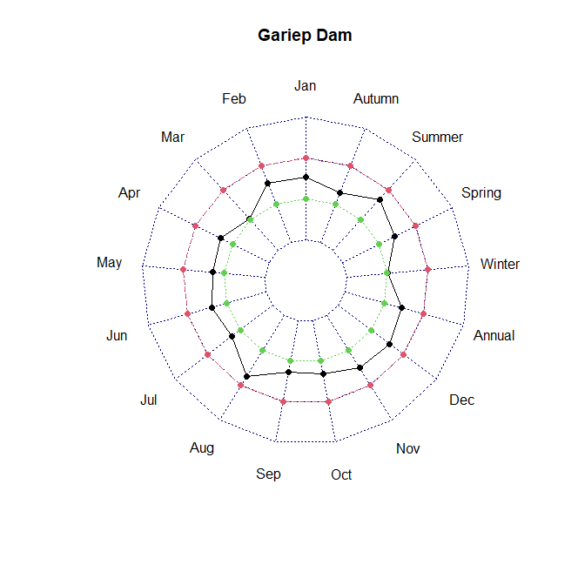

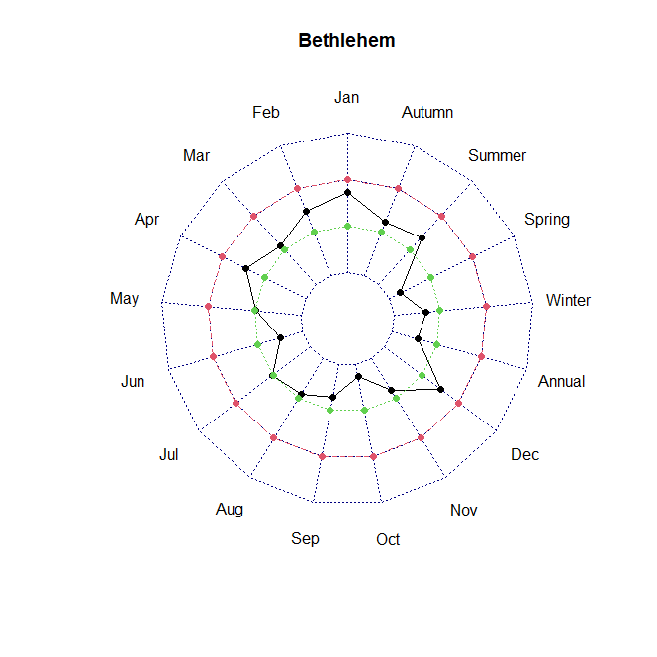

## 1.1.3 Temperature Concentration Index

TCI is a new index for displaying the uniformity distribution of temperature that the basic idea is derived from the PCI. The classification table is given in chapter 2. For all the stations have a TCI index which is less than 10, indicating that the temperature is uniform for all the stations which indicates that for whole province of the Free State the temperature has a uniform distribution.

# 1.2 Precipitation

## 1.2.1 Pettitt test

The introduction for Pettitt test is in section 1.1.1.

The precipitation has very few significant change-points for the seven studied stations. The change-points are all downwards. The change-points are observed in August and Spring. Out of the seven stations studied only 3 has a significant change-points in spring. Only BloemWo, Bethlehem and Vrede that has a significant change-point.

Table 3: Pettitt test results for precipitation

|  |  |  |  |  |  |  |
| --- | --- | --- | --- | --- | --- | --- |
| **Timescale** | **Gauge Station** | **P-value** | **Change point** | **Average Before shift** | **Average After shift** | **Shift** |
| August | Vrede | 0.0369 | 2006 | 30.1 | 0.0 | Down |
| Spring | BloemWo  Bethlehem  Vrede | 0.0370  0.0266  0.0284 | 2009  2007  2007 | 35.9  89.3  60.0 | 9.8  8.4  11.5 | Down  Down  Down |

## 1.2.2 Mann-Kendall

The introduction of Mann-kendall test is given in 1.2.1.

Out of seven stations studied, only Bethlehem and Vrede have a significant trend. Most of the trend is downwards which suggest decrease in precipitation levels over time. Vrede has a downward trend in precipitation while Bethlehem has a upward trend in December and downward trend in spring.

Table 4: Mann-Kendal trend results for precipitation

|  |  |  |  |  |  |
| --- | --- | --- | --- | --- | --- |
| **Timescale** | **Gauge Station** | **P-value** | **Z value** | **Sen’s slope** | **Trend direction** |
| October | Vrede | 0.0135 | -2.4705 | -1.669 | Downward |
| December | Bethlehem | 0.0128 | 2.4908 | 1.825 | Upward |
| Spring | Bethlehem  Vrede | 0.0251  0.0081 | -2.2396  -2.6479 | -0.533  -0.908 | Downward  Downward |
| Annual | Vrede | 0.0283 | -2.1390 | -0.677 | Downward |

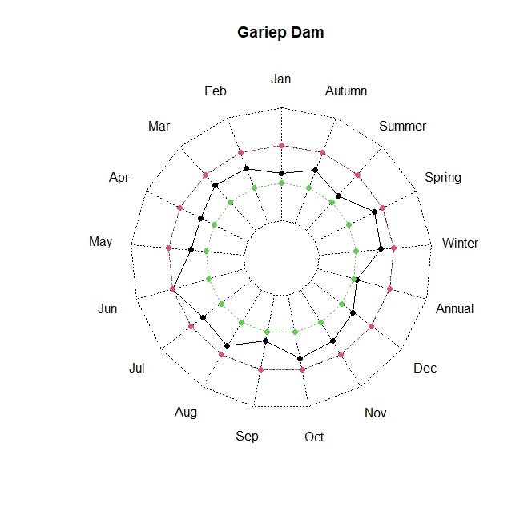

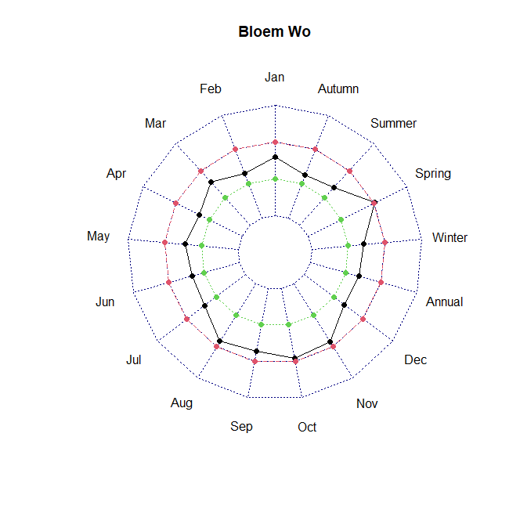

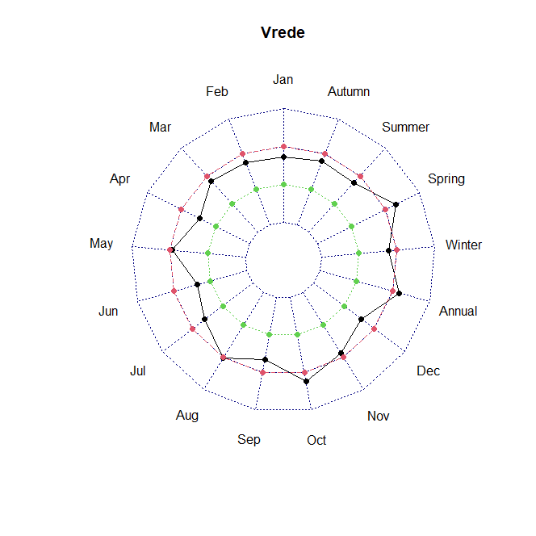

## 1.2.3 Modified Fournier Index

As previously mentioned in Chapter 2, MFI is used to measure the erosivity power of rainfall. In chapter 2, section 2.6, a table is provided to classify the aggressiveness of the rainfall. Below is the figure 3 that shows MFI for each station. The red line is the cut off value of 120, for which, any MFI above this value shows rainfall aggressiveness is severe to very severe. Below the red line shows very low to moderate rainfall aggressiveness. Most of the stations in the Free State province have an average MFI that is below 90 which indicates very low to moderate rainfall power. Only Bethlehem has experienced a very aggressive rainfall over the years.

## 1.2.4 Precipitation Concentration Index

PCI, as explained in the first chapter, that, is a powerful indicator for temporal precipitation distribution and is traditionally applied on an annual scale. The classification table is given in chapter 2. All of the stations have an average PCI which is above 15, which suggests that all the stations have irregular to strong irregular precipitation concentration.

